 | Age 1 | Age 2 | Age 3 | Age 4 | Age 5
Method 1 | 0.409 | 0.456 | 0.454 | 0.452 | 0.385
Method 2 | 0.400 | 0.433 | 0.444 | 0.435 | 0.362
Method 3 | 0.256 | 0.203 | 0.218 | 0.248 | 0.225
Method 4 | 0.081 | 0.075 | 0.037 | 0.080 | 0.107

Table 1. Coverage of nominal 50% bootstrap intervals for proportion at age.

 | Age 1 | Age 2 | Age 3 | Age 4 | Age 5
Method 1 | 0.029 | 0.063 | 0.060 | 0.046 | 0.026
Method 2 | 0.028 | 0.060 | 0.059 | 0.044 | 0.024
Method 3 | 0.016 | 0.030 | 0.029 | 0.024 | 0.015
Method 4 | 0.005 | 0.010 | 0.005 | 0.008 | 0.006

Table 2. Standard deviations of bootstrap estimates of proportion at age.

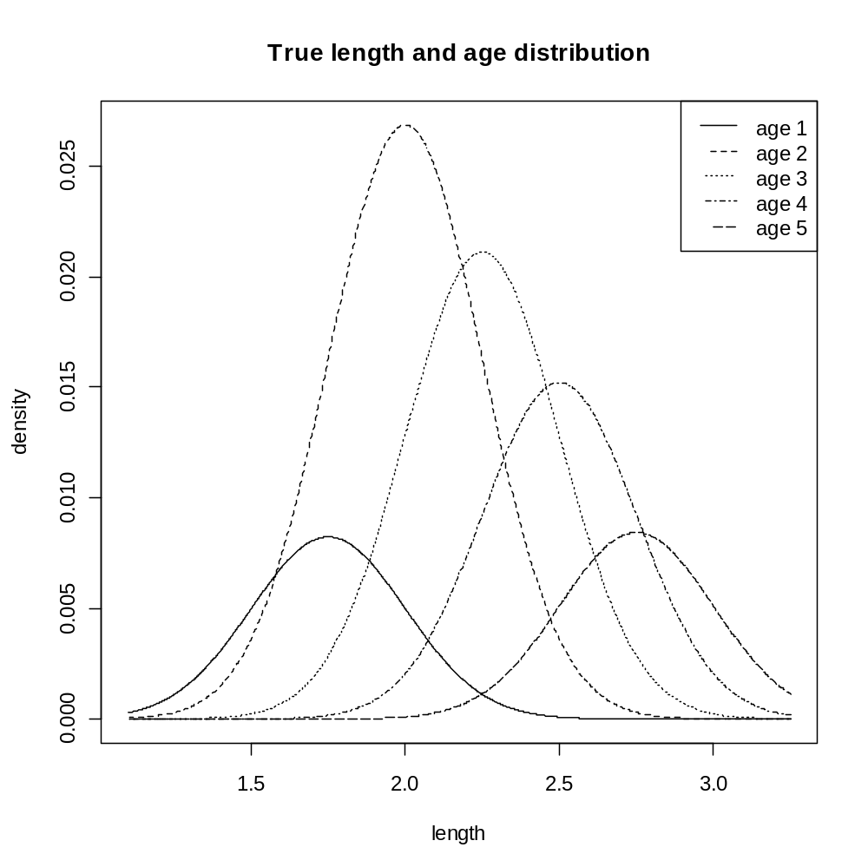
Figure 1. True stratum length and age distributions used for simulations.

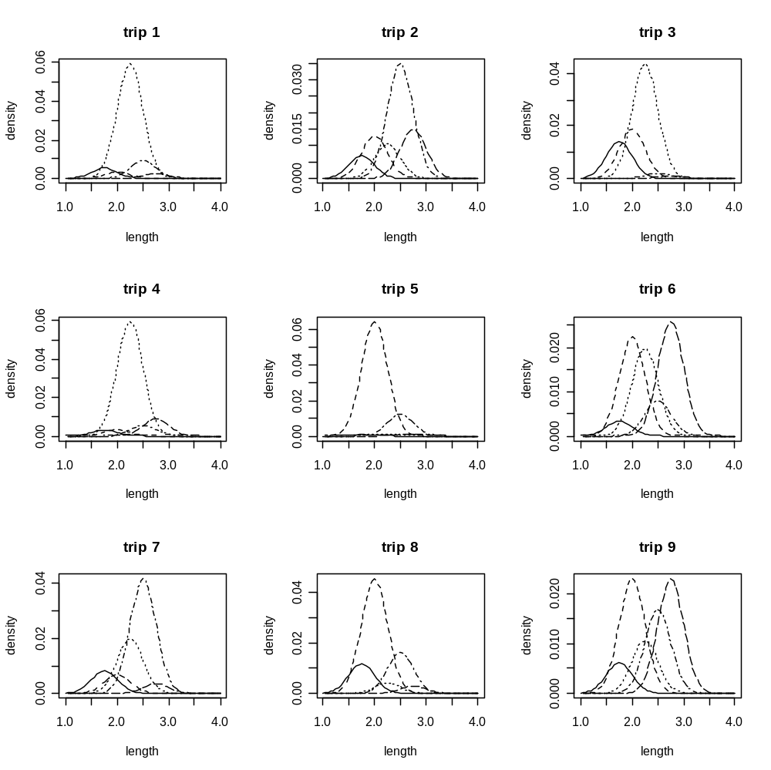
Figure 2. Length and age distributions for 9 random trips.
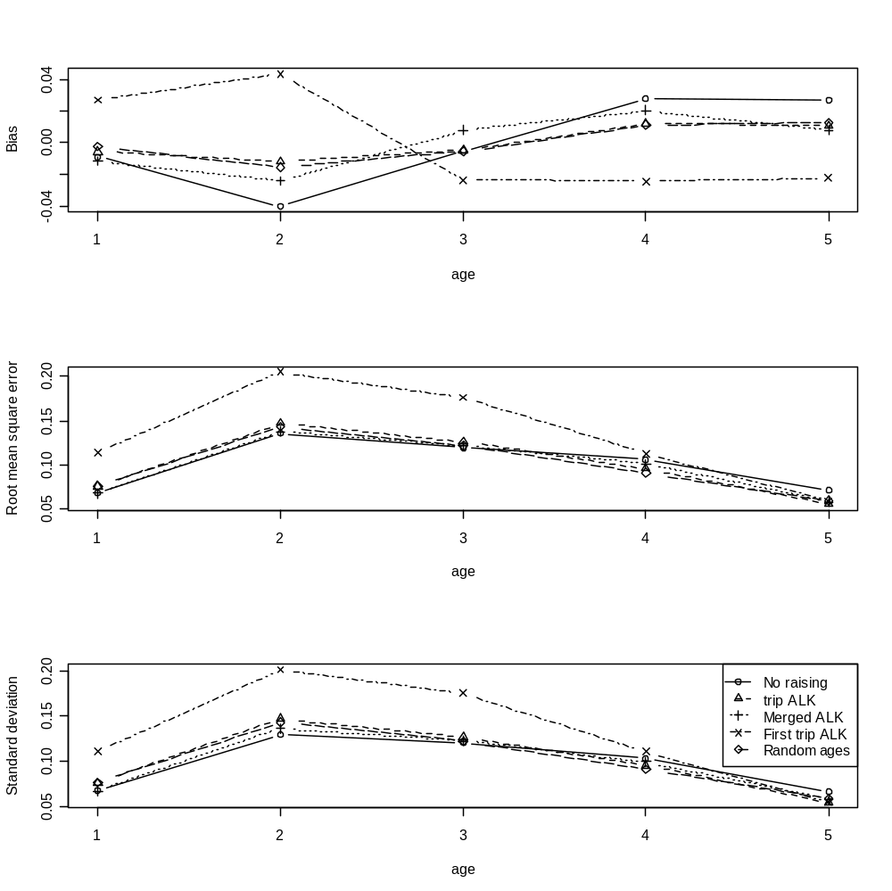
Figure 3. Bias, root mean square error and standard deviation of esimates of proportion at age by 5 different methods. 3 trips were used in the simulation, and age and length samples taken from all of them.
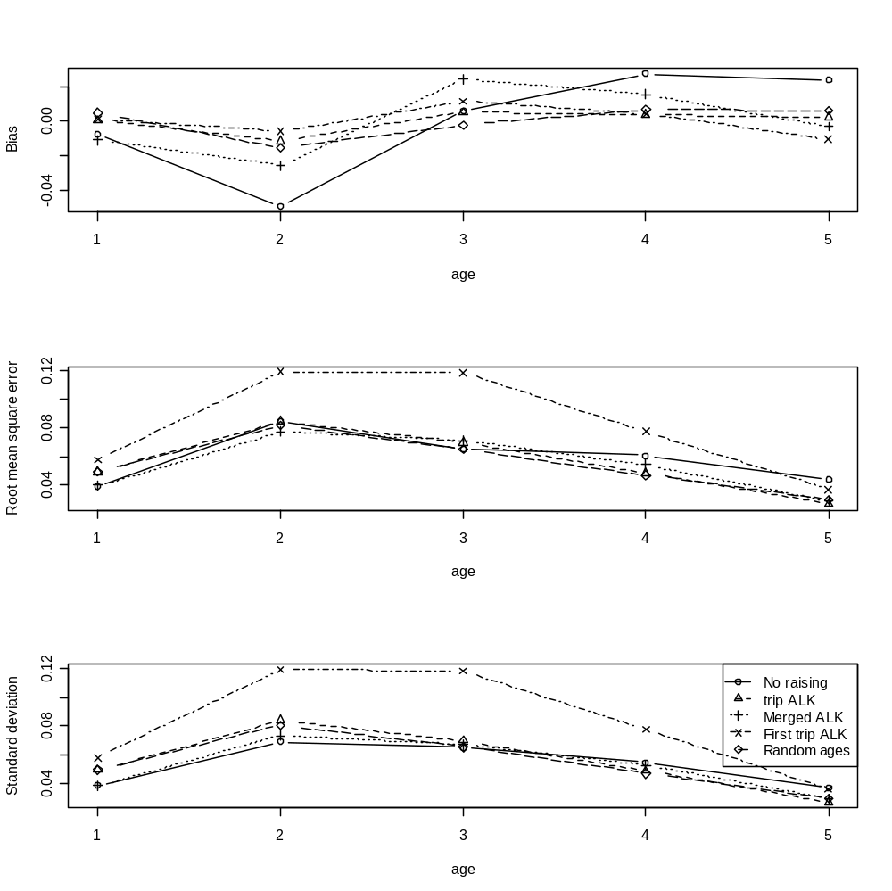
Figure 4. Bias, root mean square error and standard deviation of esimates of proportion at age by 5 different methods. 10 trips were used in the simulation, and age and length samples taken from all of them.
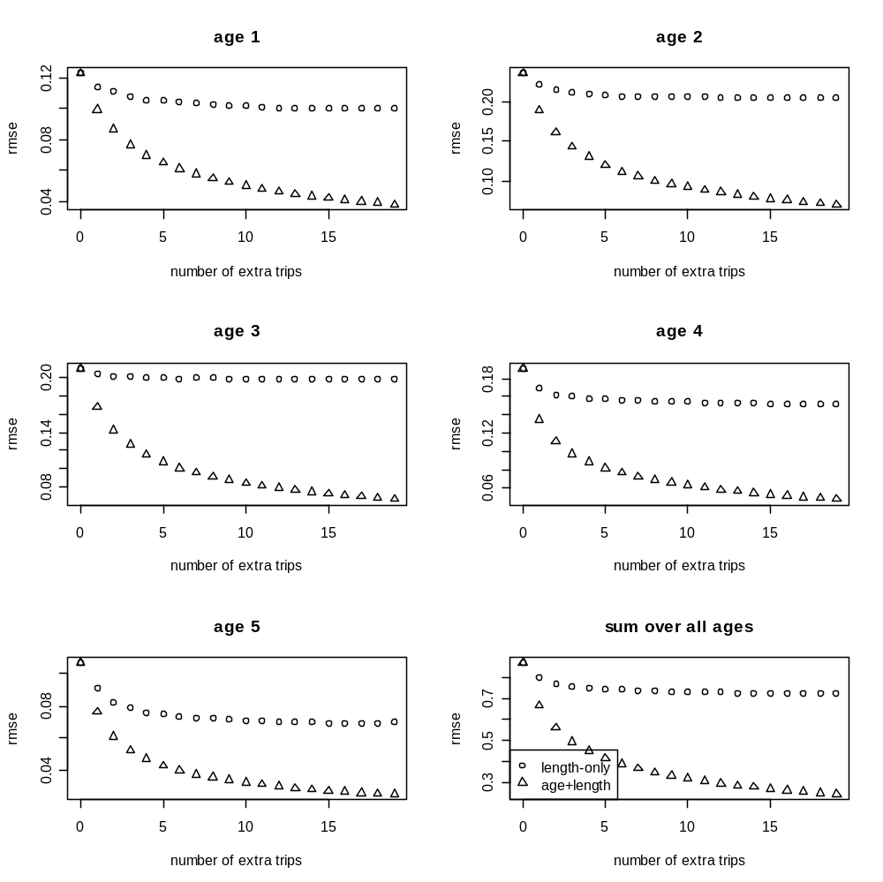
Figure 5. Comparison of the benefit of sampling additional trips for length only or for age and length. The starting point is 1 trip with age and length data. The benefit of taking length only samples has an asymptote, which can be bettered by taking only 1 extra trip with age data.

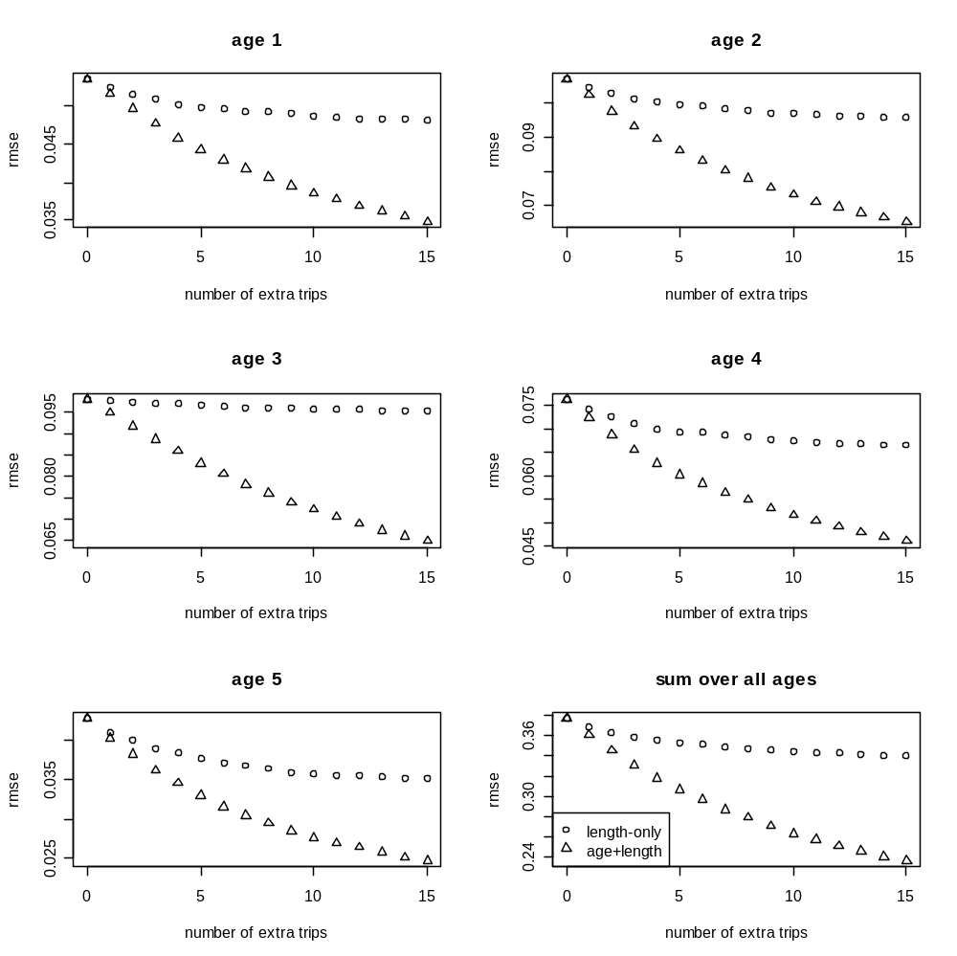

Figure 6. Comparison of the benefit of sampling additional trips for length only or for age and length. The starting point is 5 trips with age and length data. The benefit of taking length only samples has an asymptote, which can be bettered by taking only 3 extra trips with age data.

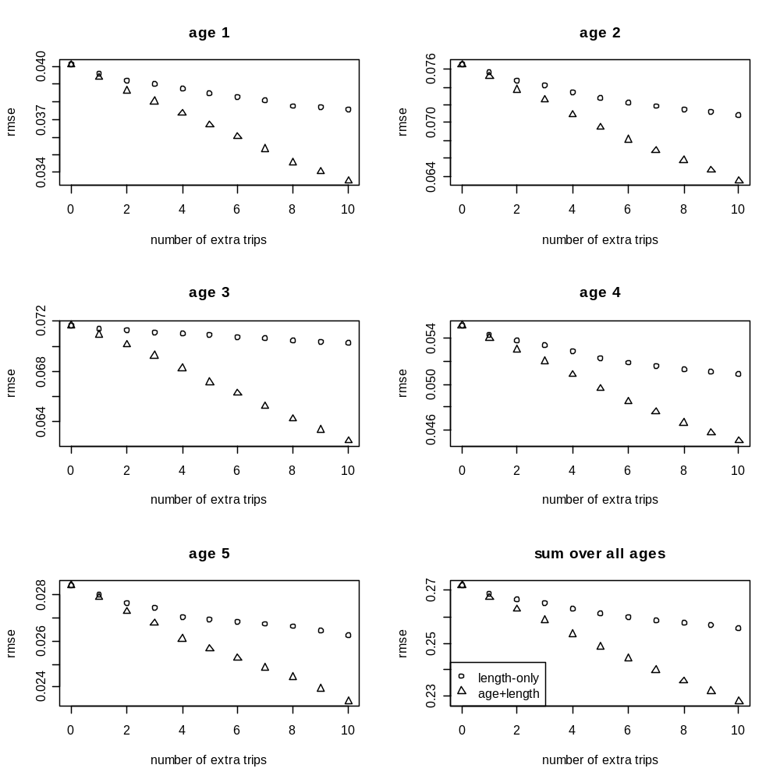
Figure 7. Comparison of the benefit of sampling additional trips for length only or for age and length. The starting point is 10 trips with age and length data. The benefit of taking length only samples has an asymptote, which can be bettered by taking only 4 extra trips with age data.

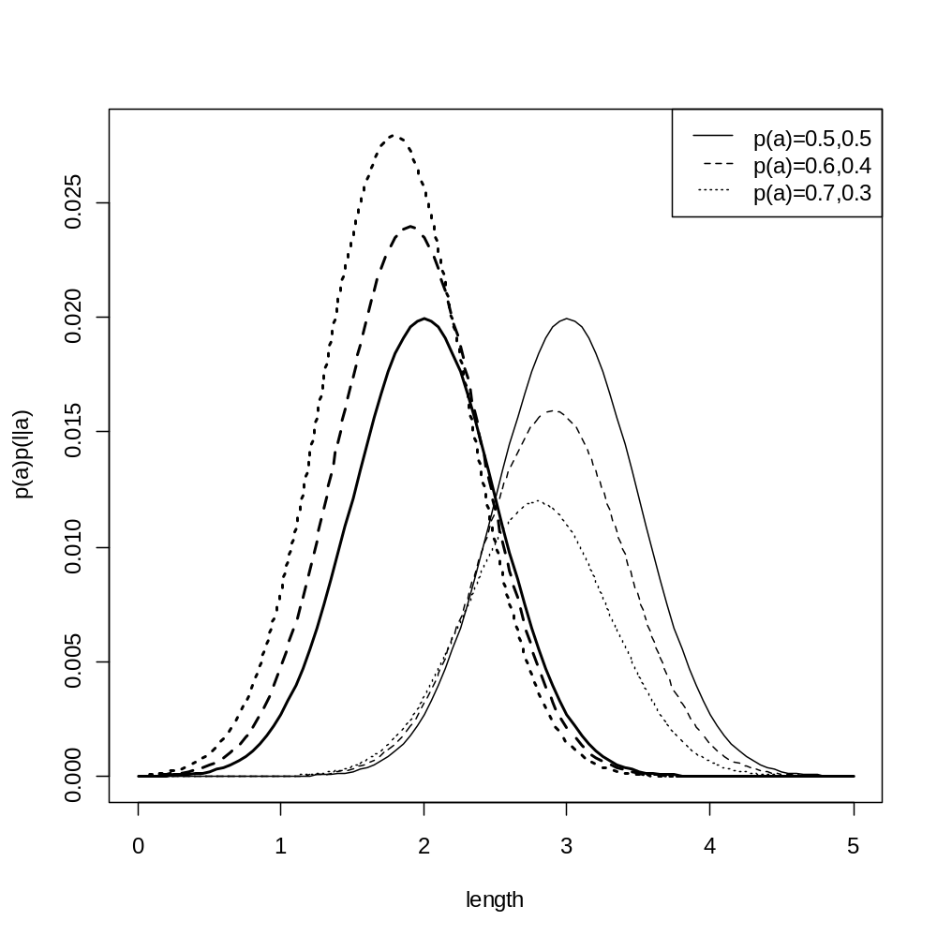
Figure 8. Changes required in distribution of length-given-age if the ALK is to remain constant despite changes in the age distribution. The solid lines show two equally common age groups with mean length at age 2 and 3, and standard deviation 0.5. These change to 1.9 and 2.9 if the probabilities change to 0.6 and 0.4, and to 1.8 and 2.8 if they change to 0.7 and 0.3. The standard deviation remains unchanged.

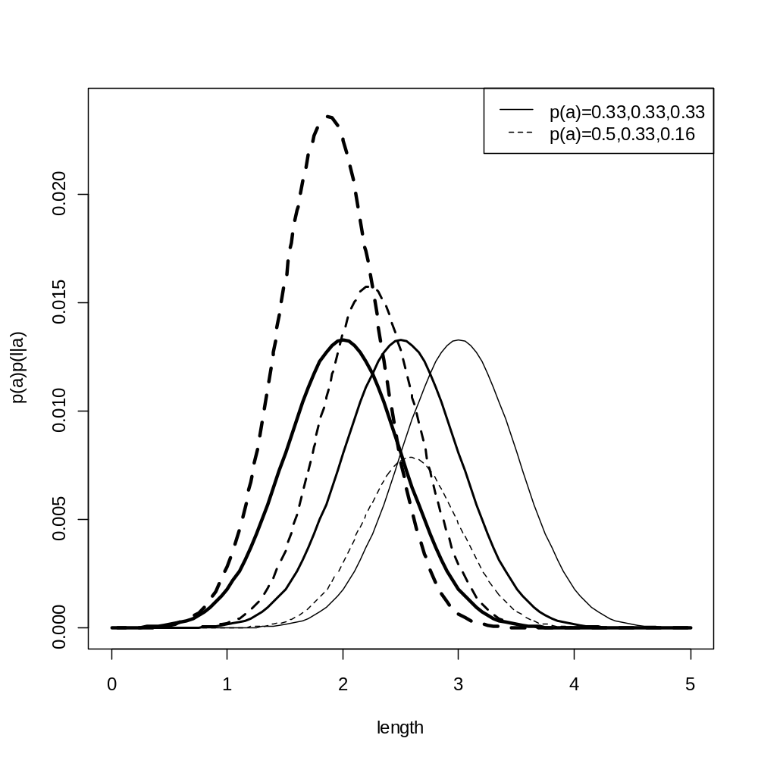
Figure 9. Changes required in distribution of length-given-age if the ALK is to remain constant despite changes in the age distribution. The solid lines show three equally common age groups with mean length at age 2, 2.5 and 3, and standard deviation 0.5. These must change to 1.87, 2.23 and 2.58 if the probabilities change to 0.5, 0.33 and 0.16. The standard deviation is reduced to 0.42.

